新 书 推 荐

中文书名：《23只狗和1只猫》
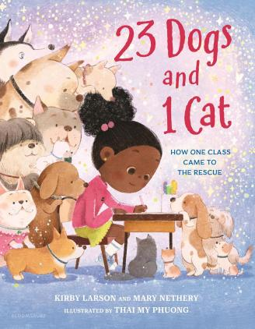
英文书名：23 Dogs and 1 Cat
作 者：Kirby Larson (Author), Mary Nethery (Author), My Phuong Thai (Illustrator)
出 版 社：Bloomsbury
代理公司：Bloomsbury/ANA
页 数：48页
出版时间：2027年2月
代理地区：中国大陆、台湾
审读资料：电子稿
类 型：故事绘本

一本温暖人心的绘本，基于一个真实故事：一个班级发起写信活动，帮助当地收容所的流浪动物找到领养家庭。

内容简介：

在这个温暖人心的故事中，孩子们可以有所作为——本书基于一个真实故事：一个二年级班级发起写信活动，帮助当地收容所的所有动物都找到了领养家庭。

鲁比(Ruby)对班级写信项目有一个大想法：他们要用劝说信帮助当地救援中心的动物找到永远的家。但真的会有人听一群孩子的话吗？让二十三只狗和一只猫都被领养并不容易，但要有所作为，你首先要做的就是尝试。

基于真实故事，这本鼓舞人心且温暖人心的绘本向孩子们展示了他们如何仅仅通过团结在一起、发出自己的声音，就能创造改变。

完美适合：
动物爱好者
书信写作课程
小活动家

媒体评论：

“A celebration of empathy and collaboration, inspired by a real-life elementary school writing project. . . . A happy reminder that anyone can make a difference.” ―Kirkus Reviews

“This excellent example of narrative nonfiction centers empathy, community service, and making a difference.” ―School Library Journal

作者简介：

Kirby Larson, the acclaimed author of the 2007 Newbery Honor Book, Hattie Big Sky, and loves collaborations, including writing Gut Reaction with her daughter Quinn Wyatt. Kirby's latest title is Shermy and Shake: The Not-So-Bossy Best Friend. 23 Dogs and 1 Cat is her third with Mary Nethery; their previous award-winning collaborations include Two Bobbies: A True Story of Hurricane Katrina, Friendship and Survival and Nubs: The True Story of a Mutt, a Marine and a Miracle. www.kirbylarson.com
Mary Nethery is the New York Times and USA Today best-selling author of picture books including the cozy read-along Hannah and Jack and shelf-favorite collaborations with Kirby Larson. For these works together, Mary and Kirby received the ASPCA Children's Book Award, The Christopher Medal, a JLG Award and the National Parenting Publication Gold Award. Mary also has an extensive background in teaching, curriculum design and staff development. She currently lives in Richmond, Virginia with her professor son nearby and her snuggly kitties Ruby Chanel and Remy Moss!
Thai My Phuong is a Vietnamese illustrator passionate about visual storytelling. With a BFA in Interior Design and an MA in Sequential Art/Illustration, she has worked with international publishers and taught illustration classes. Phuong currently lives in Chicago with her husband and a cat. Visit her work at https://thaiphuong.net.

内页插图：

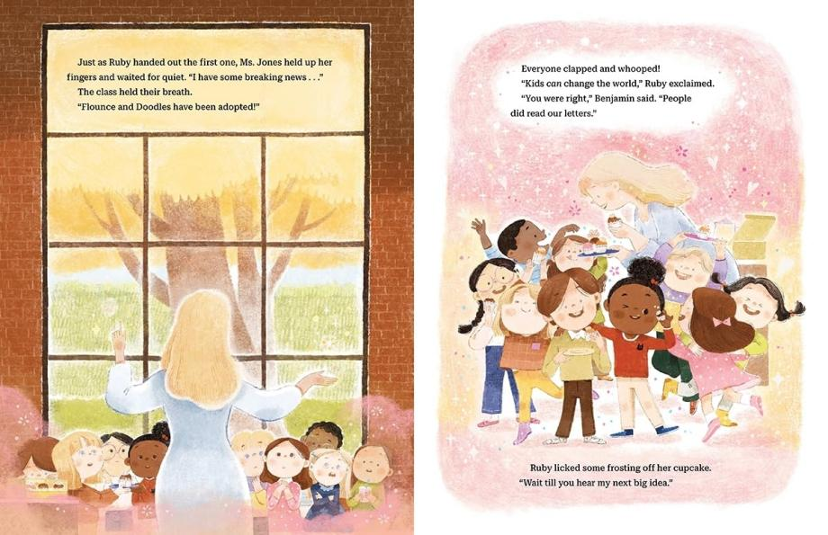
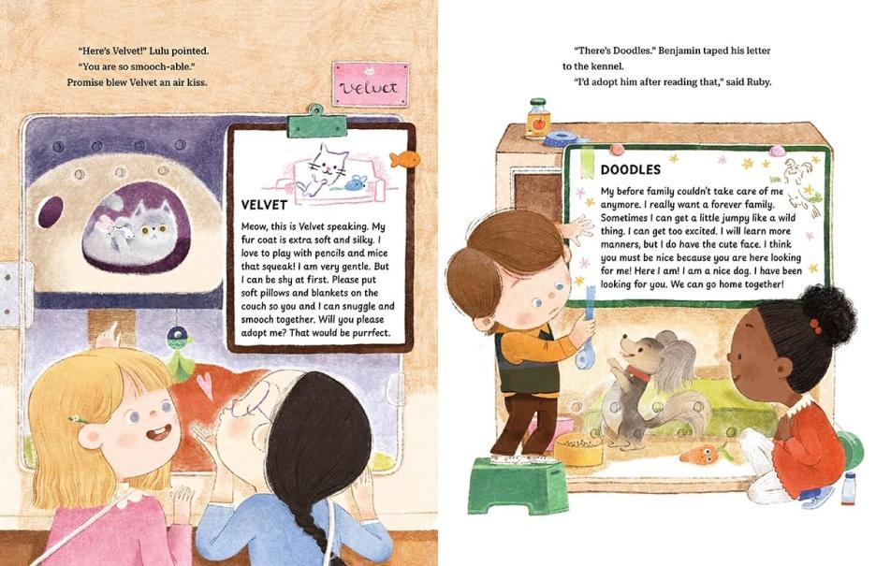

请将反馈信息发至：版权负责人
Email：Rights@nurnberg.com.cn
安德鲁·纳伯格联合国际有限公司北京代表处
北京市海淀区中关村大街甲59号中国人民大学文化大厦1705室, 邮编：100872
电话：010-82504106, 传真：010-82504200
公司网址：http://www.nurnberg.com.cn
书目下载：http://www.nurnberg.com.cn/booklist_zh/list.aspx
书讯浏览：http://www.nurnberg.com.cn/book/book.aspx
视频推荐：http://www.nurnberg.com.cn/video/video.aspx
豆瓣小站：http://site.douban.com/110577/
新浪微博：安德鲁纳伯格公司的微博_微博 (weibo.com)
微信订阅号：安德鲁纳伯格联合国际北京代表处

